INSECTICIDES INDIA LTD.
PLOT NO. Z/50,
PART - I, DAHEJ-SEZ
TALUKA- VAGRA -392130
DISTRICT- BHARUCH. GUJARAT (INDIA)
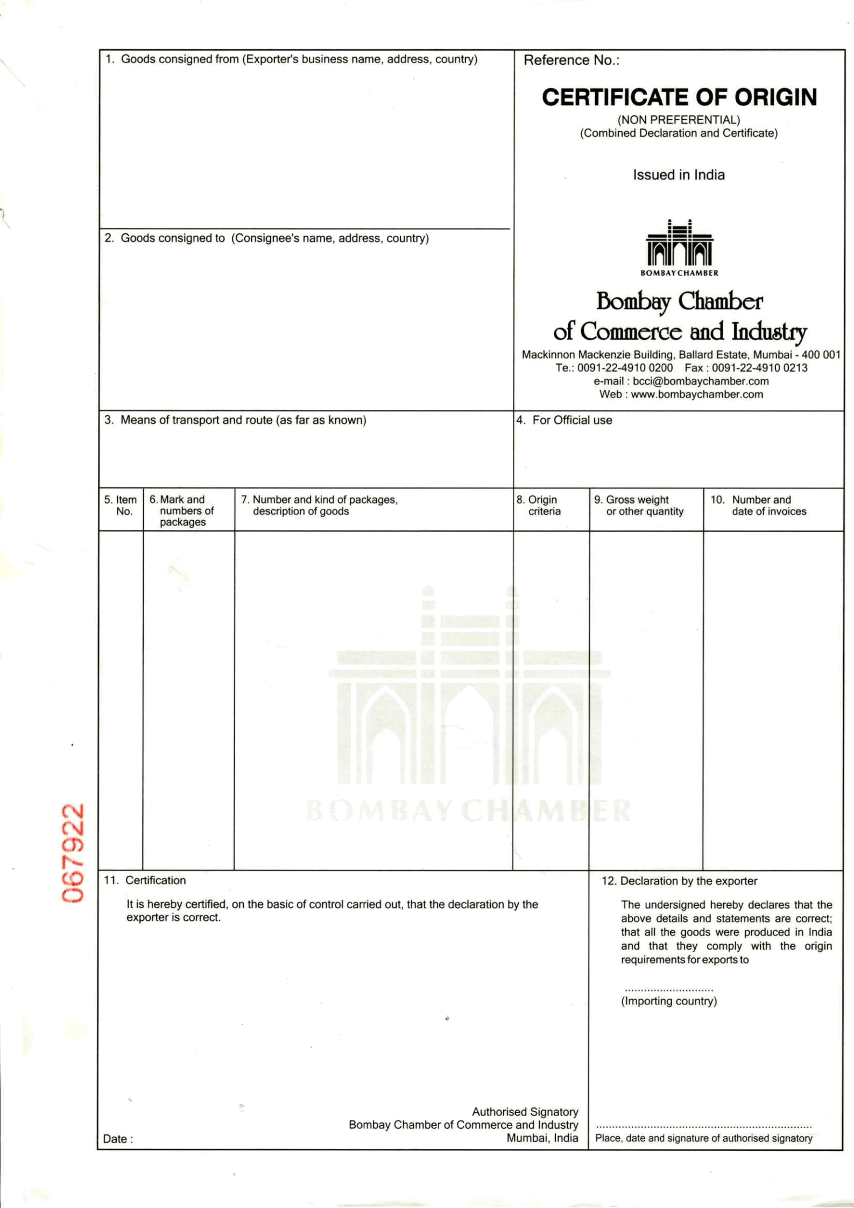
GSTIN - 24AAACI3076P2ZA

TOPEX AGRO-ELEVAGE DEVELOPPEMENT COTE
D'IVORE-SARL
TREICHVILLE ZONE 2, 4EME IMMEUBLE RMJ,
SGBCI BOULEVARD DE MARSEILLE,
12 BP 2062, ABIDJAN 12
TEL: +225-21242576/79
CONTACT PERSON ; MR. BRIJESH SHAH

HAZIRA , INDIA TO PORT ABIDJAN, IVORY COAST
VESSEL & VOY : MAERSK KLAIPEDA Voyage No – 035W

COUNTRY 1x40 ft DRY FCL CONTS INDIA GROSS WEIGHT INV.NO. 06 IVORY COAST 2250 CORRUGATED BOXES ONLY : 23580.00 KG
2250 Corrugated Boxes
ORIGIN INSECTICIDES FOR AGRICULTURE PURPOSE NET WEIGHT : Invoice Dtd: INDIA LAMBDA CYHALOTHRIN 2.5% EC(W/V : 22500.00 KG 03.09.2020
C-BOX. 01-2250 (H.S. CODE NO . 3808.91.99)
BATCH NO. D0050 PACKING: 1 LTR X 10 PET BOTTLE = 10 Ltr
Qty : 22500 LTR “WE CERTIFY THAT
UN no. : 3351, Class :6.1 Packing Group :III THE GOODS ARE INDIAN ORIGIN.”

CONTAINER NO.
MSKU9962090(40'ft)

SHIPPING LINE SEAL NO
ML-IN3070033 INV NO.: 06/03.09.2020
SB NO: 4011005 DATED..03.09.2020
BL NO. 911175406 DATED.00.09.2020
IEC NO: 0501068023 BRANCH NO. 11

IVORY COAST
DATE: 05.09.2020

